**Transformations task**

CREATE TABLE countryRank AS

select DISTINCT (DENSE_RANK() OVER (PARTITION BY continent, region ORDER BY area DESC)) as rank, continents.name as continent, regions.name as region, countries.name as country, countries.area as area, countries.country_code3 as ccode3, (CASE WHEN countries.national_day IS NULL THEN "no data" ELSE (CASE WHEN DATEDIFF( CURDATE(), countries.national_day) < 0 THEN CURDATE() ELSE countries.national_day END) END ) as nday

from regions

inner join continents on continents.continent_id = regions.continent_id

inner join countries on regions.region_id = countries.region_id

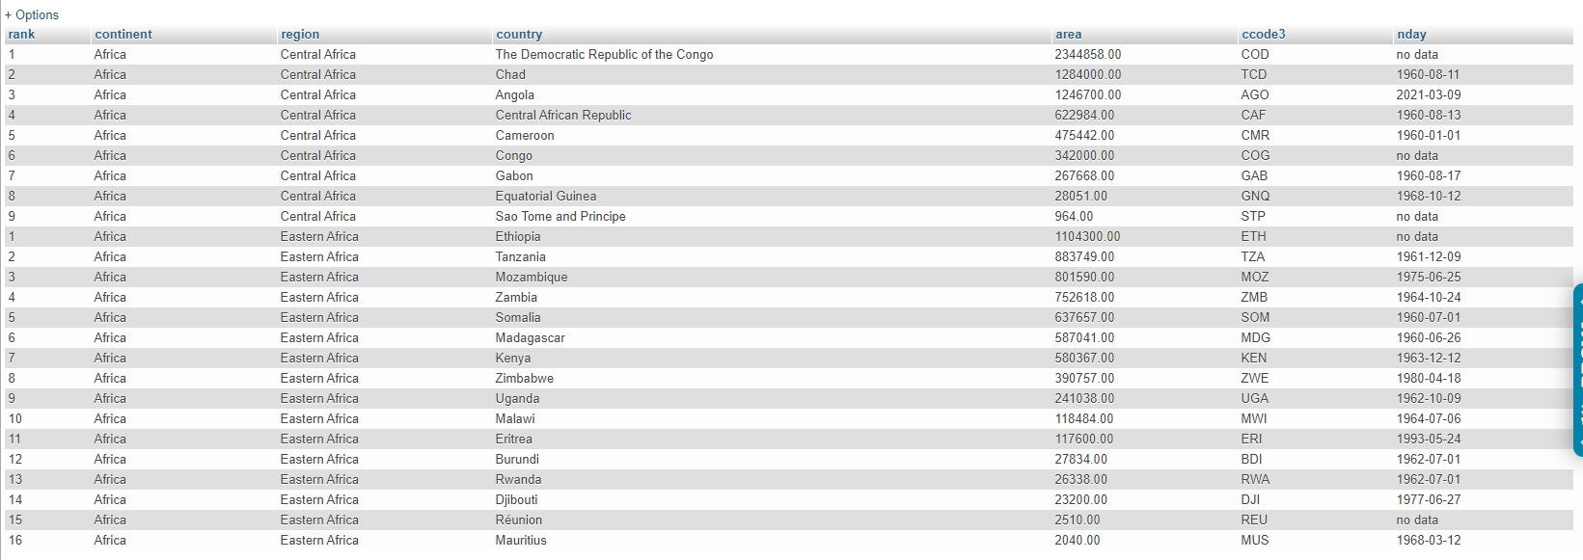

What can be done on a database level to avoid problems with duplicates and Null values?

При создании таблицы использовать ключевые слова NOT NULL и UNIQUE на значение поля не может быть NULL, example

*CREATE TABLE Example (*

*TheValue INT NOT NULL,*

*OtherValue INT,*

*UNIQUE (TheValue)*

*)*